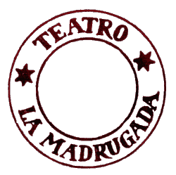

REGULA CONTRA REGULAM
Research Programme on Performing Arts

Open work session
with the assistance from Gappad Theatre
Directed by
Raul Iaiza, Teatro La Madrugada, Italy

GLASGOW, 1st – 3rd JULY 2011
at GTAC - Glasgow Theatre and Arts Collective base
4th floor, 7 Water Row, Govan, Glasgow G51 3UW

APPLICATION FORM
please send to info@gappadtheatre.co.uk

FIRST NAME

SURNAME

MALE/FEMALE

AGE

NATIONALITY

E-MAIL ADDRESS

PHONE NUMBER

EDUCATION

PROFESSION

THEATRE EXPERIENCE

What is your motivation to participate in the seminar?

